Oops Notes
Object-Oriented Programming (OOP) is a programming paradigm that organizes code into objects, which represent real-world entities. It allows developers to model complex systems by breaking them down into smaller, manageable pieces.

Imagine a car manufacturing company. To produce cars, the company uses a design blueprint. The blueprint defines the structure and functionality of a car (e.g., the number of wheels, type of engine, color, etc.).
However, the blueprint itself is not a car—it is only a guide. The actual cars manufactured from this blueprint are like objects, and the blueprint itself is a class. 🚗📏

📋 What is a Class?
A class is a blueprint for creating objects. It defines the properties (attributes) and behaviors (methods) that the objects will have. Think of it as a template that outlines the structure and capabilities of an object but does not represent any actual instance. 🏗

Key Characteristics of a Class:
- Attributes (State): These are variables defined within the class that describe the characteristics of the object. 📝
- Methods (Behavior): These are functions defined in the class that describe what the objects can do. 🔧
- Constructor: A special method used to initialize the attributes of the class when an object is created. 🛠
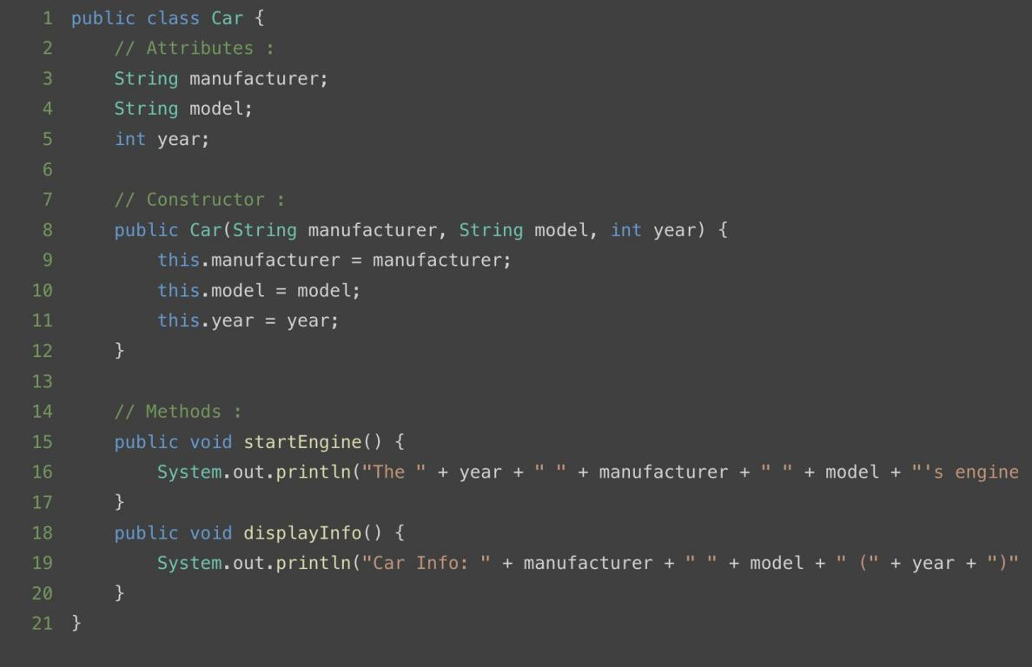

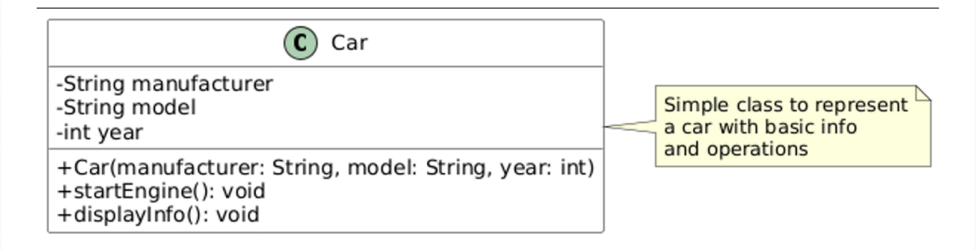

⚡What is an Object?
An object is an instance of a class. It represents a specific realization of the class blueprint, with its own unique set of data.

In the car analogy, each manufactured car is an object, and it holds specific values for its attributes (e.g., make: "Toyota", model: "Corolla", year: 2021).

🔑Key Characteristics of an Object:
- State: Represented by the object’s attributes.
- Behavior: Defined by the methods the object can execute.
3 Identity: A unique reference to the object in memory.

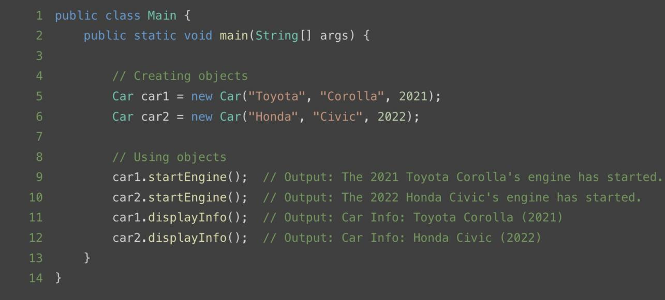

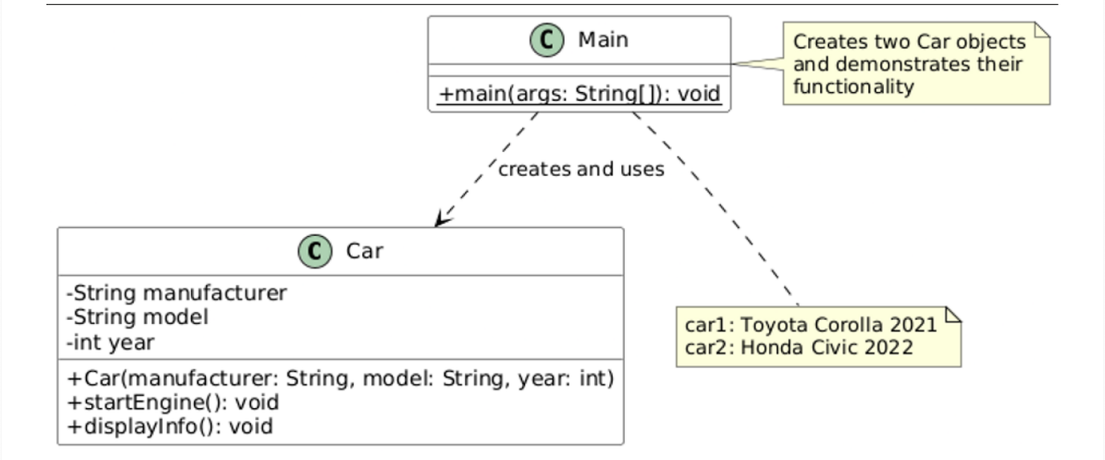
Here, car1 and car2 are objects of the Car class, each holding specific data for the attributes and performing actions through methods.

Real-World Analogy:
A car manufacturing blueprint is a perfect analogy for understanding classes and objects:
- Blueprint (Class): It specifies the design and functionality of the car but does not represent an actual car. 🏗🚗
- Cars (Objects): Each car produced from the blueprint is unique, with specific values for attributes like color, manufacturer, and model Number, but all cars share the same general
structure and behavior defined by the blueprint. 🌟

For example:
  - Blueprint: Car design with details like "4 wheels," "engine capacity," "fuel type." 🛠🔧

  - Objects:
- Car 1: A red Hyundai i20, 1.8L engine capacity and petrol fuel type. 🔴🚗
- Car 2: A blue Honda Civic, 2.0L engine capacity and diesel fuel type. 🔵🚙

🤔 Why Use Classes and Objects?
- Reusability: Write a class once and create multiple objects with different data. ♻
- Modularity: Classes help organize code into logical sections, making it easier to debug and maintain. 🧩
- Abstraction: Focus on the essential details of an entity without worrying about the internal workings. 🔍
- Scalability: Adding new features is straightforward without affecting existing code. 📈

Constructors are special methods in object-oriented programming used to initialize objects of a class.

They play a pivotal role in ensuring that an object is in a valid state right after it is "created". Unlike regular methods, constructors have the same name as the class and do not have a return type. 🔧

🛠Key Features of Constructors:
- Automatic Invocation: Constructors are called automatically when an object of the class is instantiated. 🔄
- No Return Type: Unlike methods, constructors do not have a return type, not even void.
🚫
- Overloading Support: You can have multiple constructors with different parameters in the same class, enabling flexibility in object initialization. 🔁

Types of Constructors:
Constructors can be broadly categorized into the following types:

Default Constructor (No-Argument Constructor):
When No Constructor Is Defined (Implicit Default Constructor):

If you do not explicitly create any constructor for a class, Java automatically provides a default constructor.

This constructor initializes instance variables to their default values based on the data type.
🔄

Default Values:
int → 0 double → 0.0
boolean → false Object → null

Example :

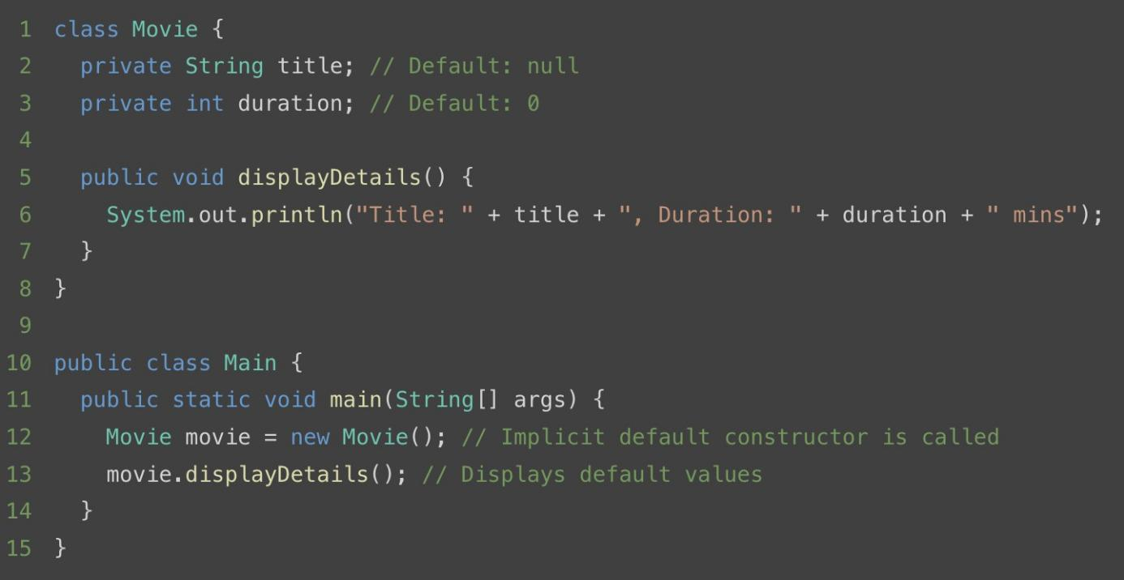
Output :
Title: null, Duration: 0 mins

Explicitly Defining a Default Constructor with Custom Values :

You can define your own default constructor to set custom default values for the class fields instead of relying on Java's implicit default values.

Example :
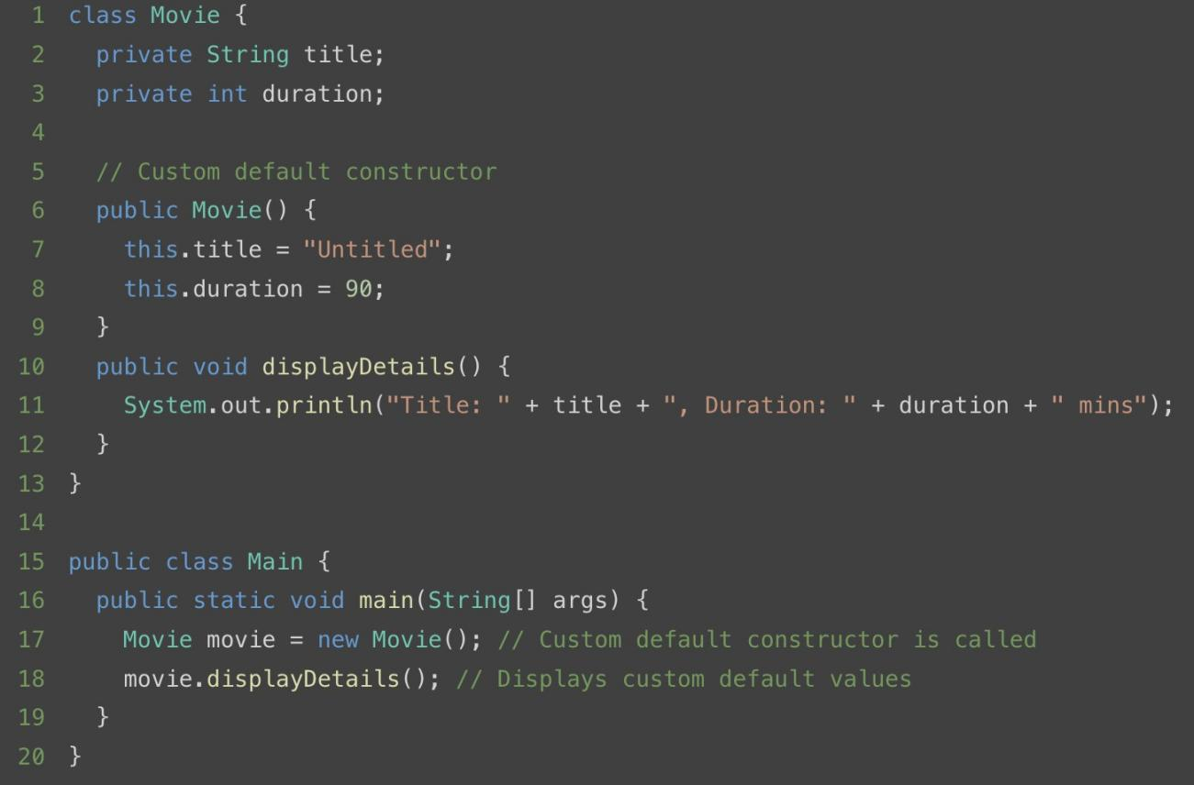

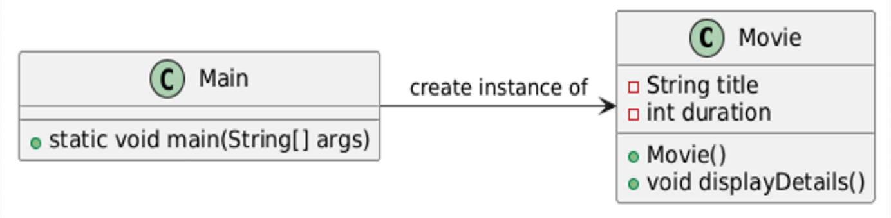
Output :
Title: Untitled, Duration: 90 mins

By explicitly defining a default constructor, you gain control over how objects are initialized, ensuring that they start with meaningful default values that match the application's requirements.

Parameterized Constructor:
A parameterized constructor takes arguments to initialize the object with specific values.
Example :
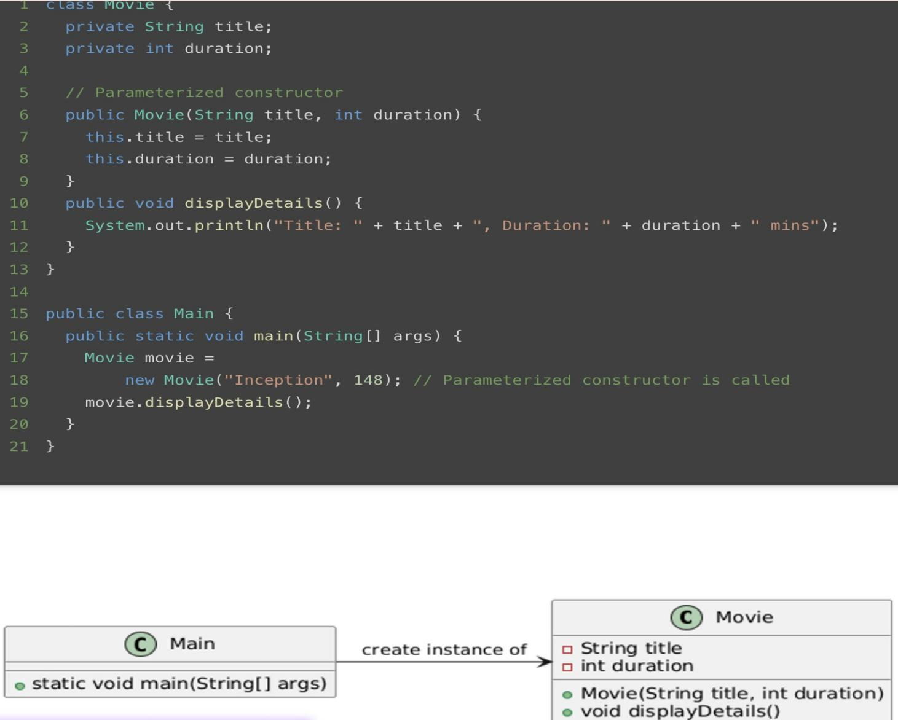

Output :
Title: Inception, Duration: 148 mins

Copy Constructor:
A copy constructor initializes an object using another object of the same class.
Example :
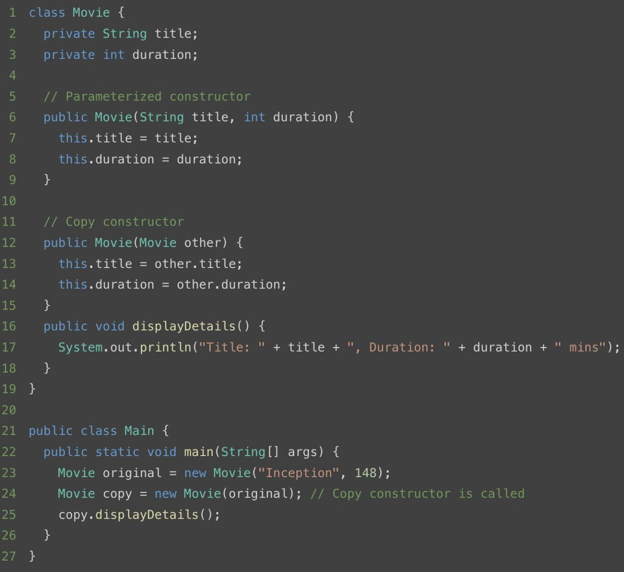
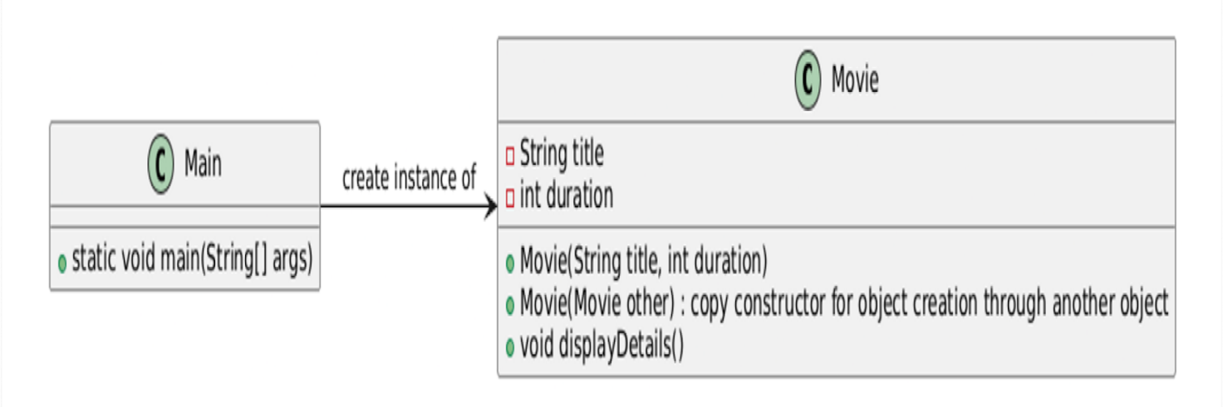

Output :
Title: Inception, Duration: 148 mins

Private Constructor:
A private constructor is used to restrict object creation from outside the class. It is commonly used in Singleton Design Pattern.
Example :
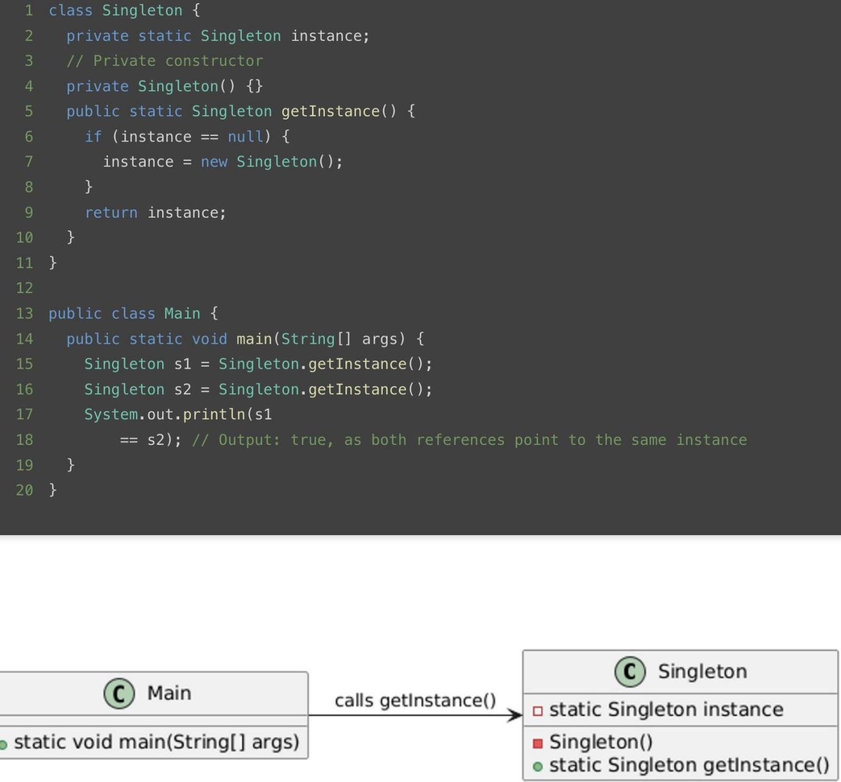

Key Points to Remember:
  - A class can have multiple constructors through overloading, but they must differ in parameter lists.

  - Constructors can call other constructors in the same class using this().

  - Constructors can call parent class constructors using super() in java.

  - Always use constructors to ensure objects are in a consistent and valid state.

  - Utilize copy constructors carefully to avoid shallow copying when deep copying is required.

  - Leverage private constructors for Singleton patterns or utility classes.

Interview Questions :
- Can a constructor be final, static, or abstract? Why or why not? Answer: No, constructors cannot be final, static, or abstract because:
  - final: A constructor cannot be inherited, so final is irrelevant.
  - static: Constructors belong to objects, not the class itself.
  - abstract: A constructor must be concrete as it initializes an object.

- What happens if you explicitly define a constructor with arguments but no default constructor?
Answer: The default constructor is not automatically provided. Attempting to create an object with no arguments will result in a compilation error.
- What happens if you create an object of a subclass? Which constructor is called first? Answer: The parent class constructor is called first, followed by the subclass constructor. This ensures proper initialization.

- What happens if a constructor is synchronized?
Answer: A synchronized constructor is allowed but makes no sense, as object-level synchronization is not applicable before the object is fully created.

- Can a constructor be inherited?
Answer: No, constructors are not inherited, but a subclass can call the superclass constructor using super().

- Can a constructor have a return statement?
Answer: No, constructors cannot return a value, but they can have a return statement to exit early (without a value).

The "this" keyword is a fundamental concept in Object-Oriented Programming (OOP) that provides a reference to the current object. Its behavior and usage are crucial in Java programming for building robust and maintainable applications. 🔧

This Keyword in Java:
The "this" keyword in Java is a built-in reference to the current object within a class's methods or constructors. It allows access to the object's properties, methods, and other members. ⚙

Why Is the "this" Keyword Important?:
- Disambiguation: Resolves naming conflicts between instance variables and parameters or local variables. 🔄
- Chaining: Enables method chaining or constructor chaining, improving code readability and structure. 🔗
- Passing References: Passes the current object as a parameter to other methods or functions. 📤
- Dynamic Binding: Refers to the current object dynamically during runtime in polymorphic scenarios. 🎭

How "this" Works in Java:

Referring to the Instance Object:
The "this" keyword is crucial when differentiating between instance variables and method or constructor parameters that share the same name. In such cases, it explicitly refers to the instance variable of the current object, avoiding ambiguity. 🛠
Example:
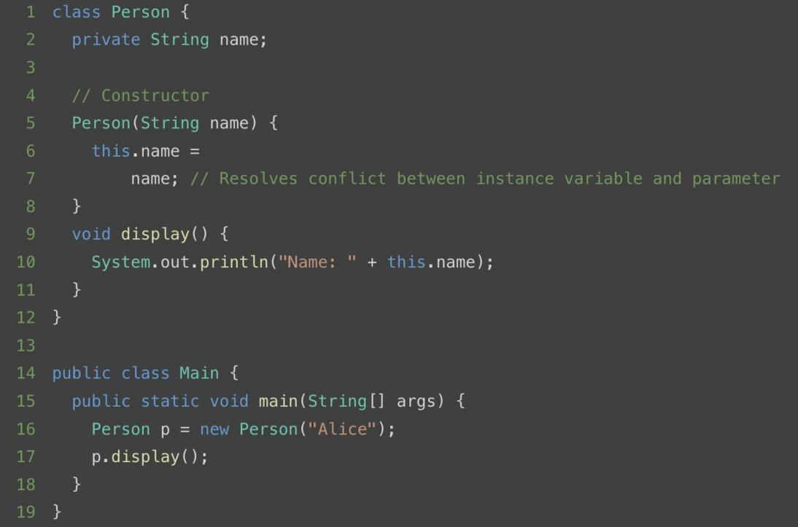

Constructor Chaining:
Using the "this" keyword for constructor chaining allows one constructor to invoke another constructor within the same class. This reduces code duplication and centralizes initialization logic, making the code easier to maintain. It also ensures that all constructors eventually delegate to a common initialization point

Example:
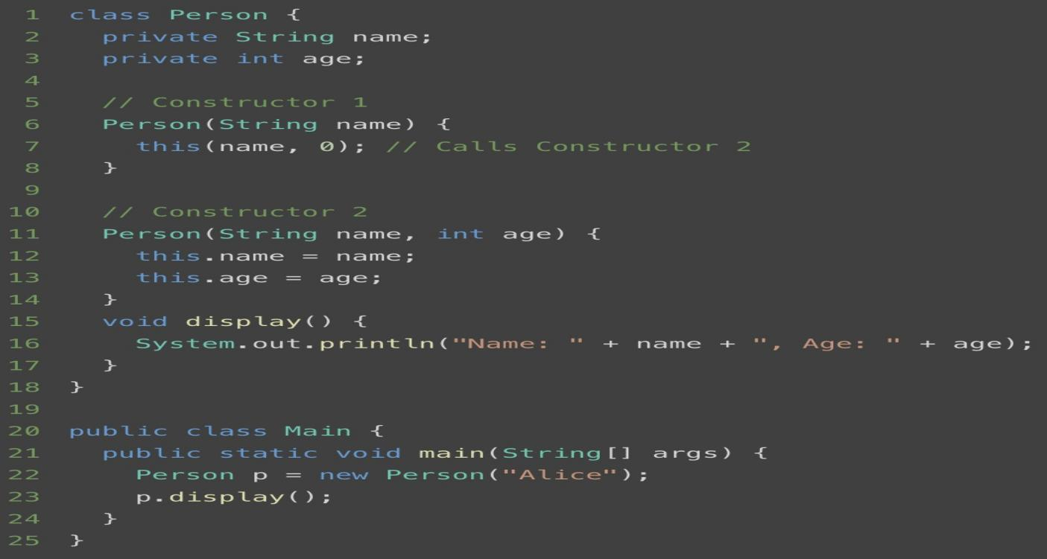

Returning the Current Object:
The "this" keyword can be used to return the current instance of a class. This approach is commonly used in implementing fluent interfaces, where multiple methods are called on the same object in a single statement. This pattern enhances code readability and provides a seamless way to chain method calls

Example:
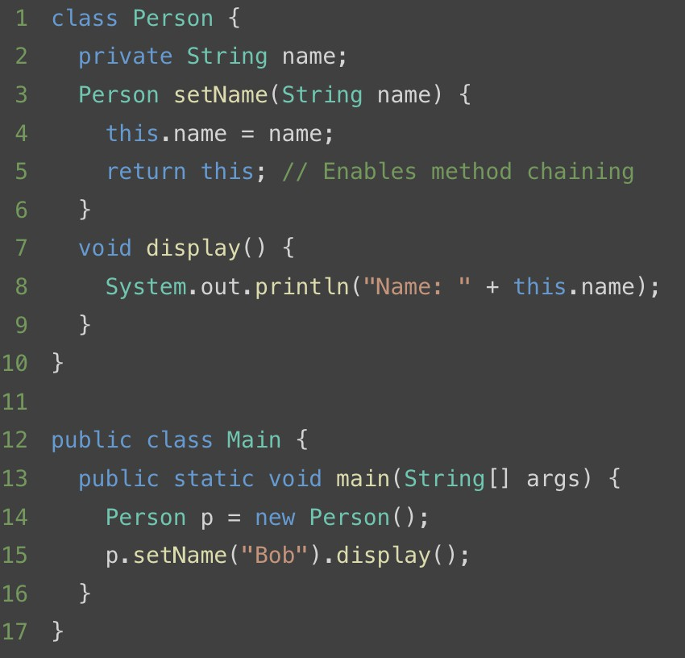

Passing the Current Object
"this" can be used to pass the current object as a parameter to another method.
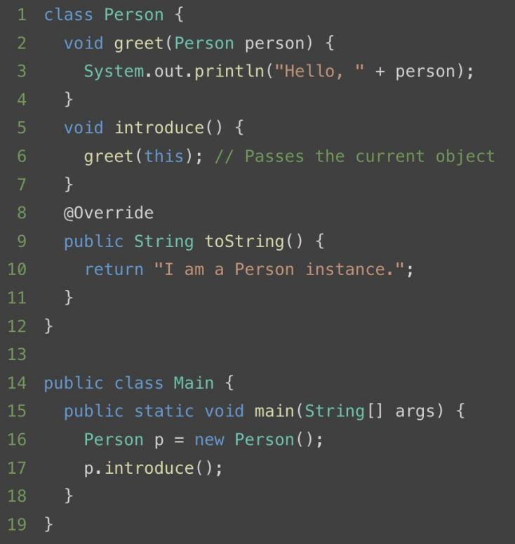

Advantages and Disadvantages of the "this" Keyword:

Advantages:
  - Enhanced Readability and Maintainability:
Using "this" improves code clarity by explicitly referencing the current object, making it easier to understand and maintain.

  - Enables Constructor and Method Chaining:
The ability to chain constructors and methods through "this" reduces redundancy and centralizes initialization or method logic, leading to more streamlined code.

  - Object Reference Passing:
Facilitates passing the current object as a parameter, enabling seamless interaction between methods or classes.

Polymorphism is one of the core principles of Object-Oriented Programming (OOP), enabling objects to take on multiple forms. It allows the same operation to behave differently on different classes, enhancing code flexibility and reusability.

A real-life example of polymorphism is a person who at the same time can have different characteristics. A man at the same time is a father, a husband, and an employee. So the same person exhibits different behavior in different situations. This is called polymorphism.
💼

In Java, polymorphism can be broadly classified into two main types:
    - Compile-time (or Static) Polymorphism
    - Runtime (or Dynamic) Polymorphism

Types of Polymorphism:

Compile-time (Static) Polymorphism:
Compile-time or Static polymorphism occurs when the method to be executed is determined at compile time. It is achieved using method overloading or operator overloading. 🛠

Method Overloading:
When there are multiple functions with the same name but different parameters, then the functions are said to be overloaded, hence this is known as Function or Method Overloading. Functions can be overloaded by changing the number of arguments or/and changing the type of arguments. 🔢🎚

Example :
  - Changing the number of arguments :

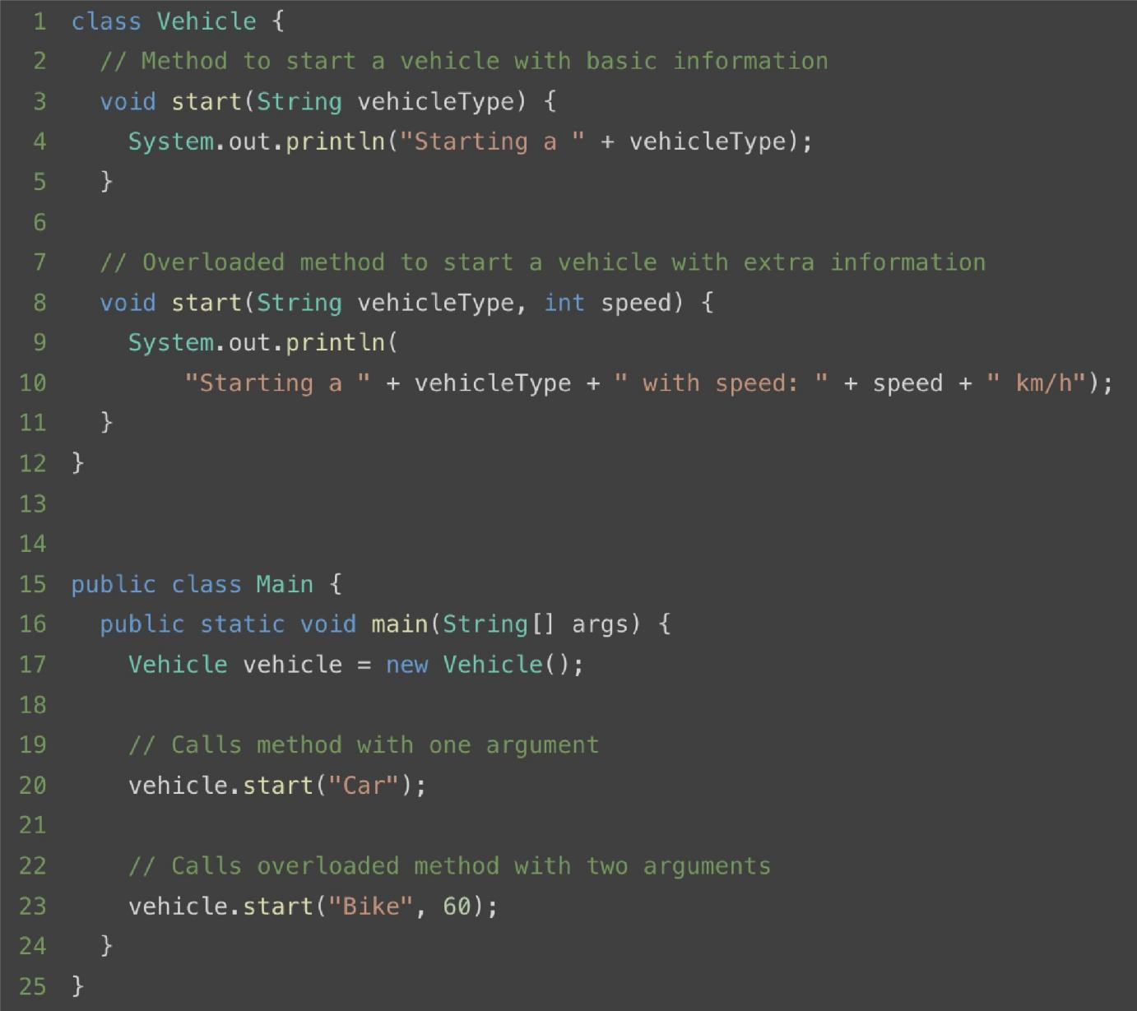

© Main
void main(String(] args)
uses

'I
© Vehicle
void start(String vehicleType)
void start(Strring vehicleType, int speed)

  - Changing the type of arguments :
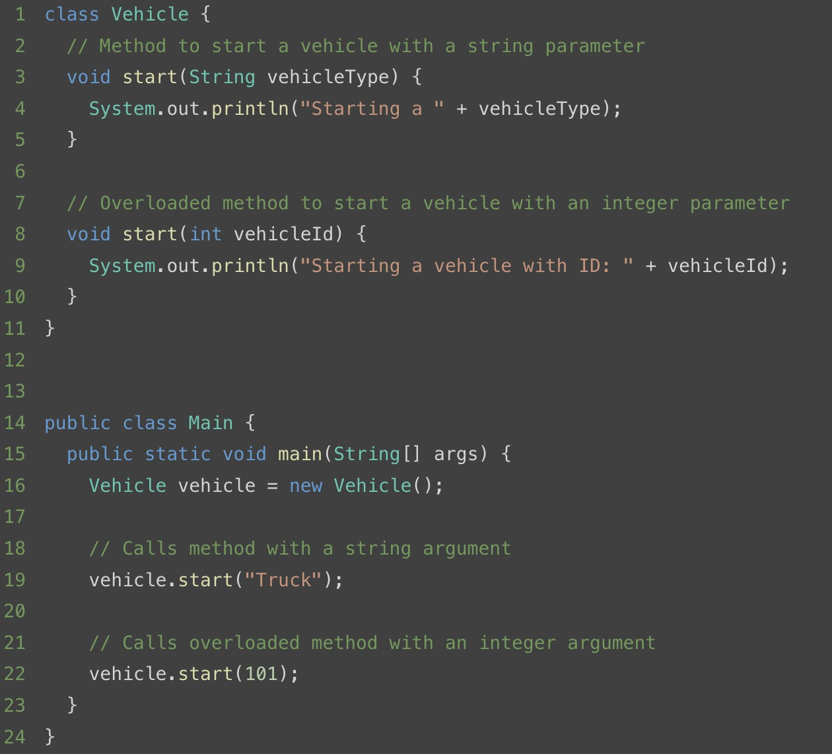
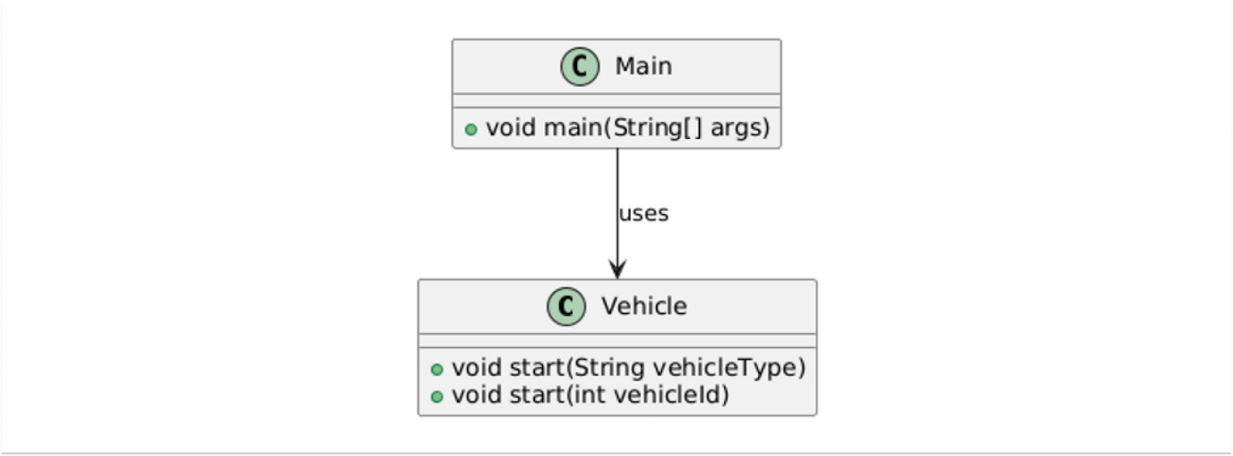

Key Features:
    - Method resolution happens at compile time.
    - Provides better readability and cleaner code by allowing methods with the same name to perform similar actions.

Runtime (Dynamic) Polymorphism :
Runtime polymorphism occurs when the method to be executed is determined during runtime. It is achieved through method overriding and is closely tied to inheritance.

Method Overriding :
Method overriding allows a subclass to provide a specific implementation for a method already defined in its parent class. The overridden method in the subclass has the same name, return type, and parameters as the method in the parent class.

Example :
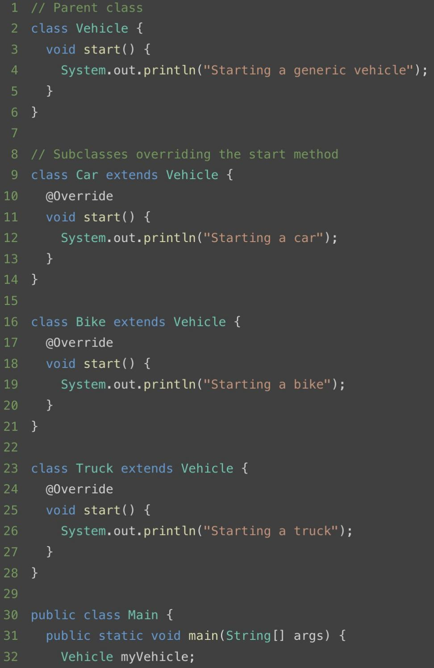

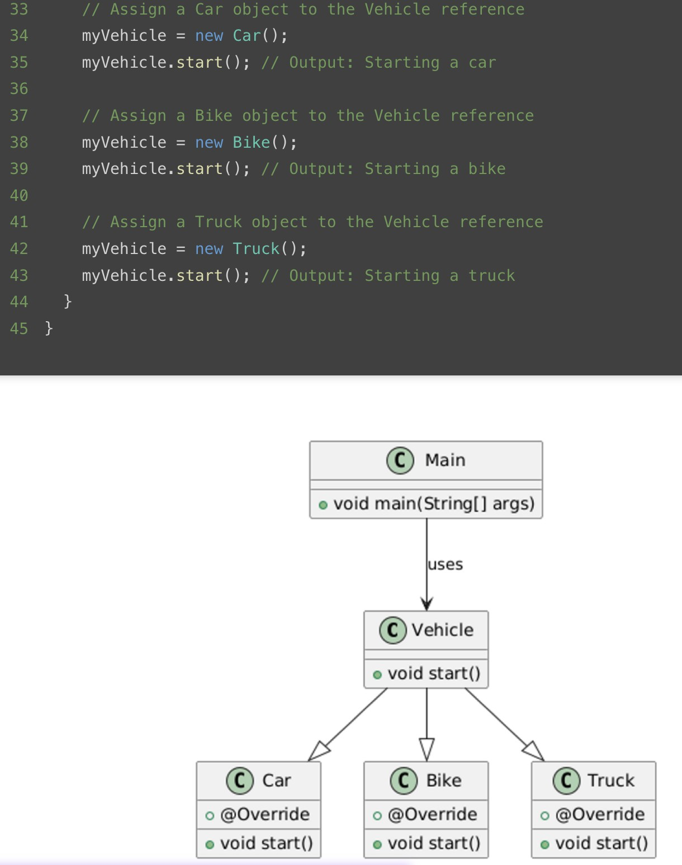
Key Features:
- Method resolution happens at runtime based on the actual object type.
- Supports dynamic method dispatch, enabling the Java Virtual Machine (JVM) to determine the appropriate method implementation.

Advantages of Polymorphism:

Code Reusability:
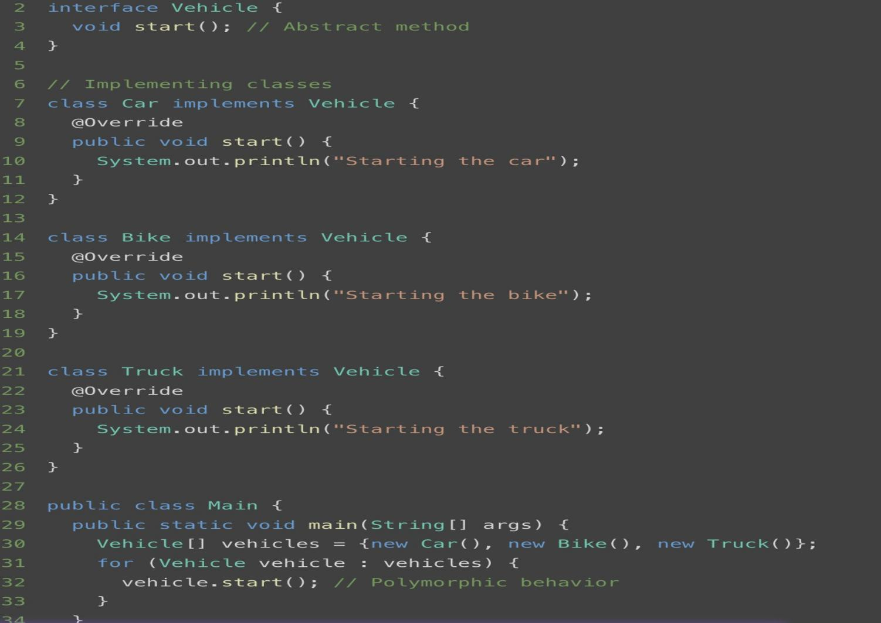
  - Encourages writing generic and reusable code by allowing a single interface to handle multiple types.
The Vehicle interface allows you to reuse a single loop (for (Vehicle vehicle : vehicles)) to handle different implementations.

Flexibility:
  - Provides flexibility in program design by enabling dynamic method behavior.

Example :
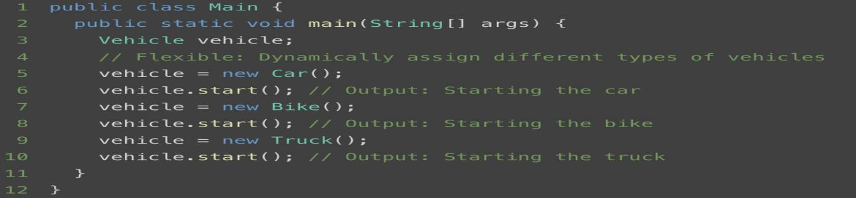

Using the Vehicle interface, we dynamically switch between different implementations (Car, Bike, Truck) at runtime.

Extensibility:
Allows easy extension of code by adding new classes / methods or overriding existing ones.

Example :
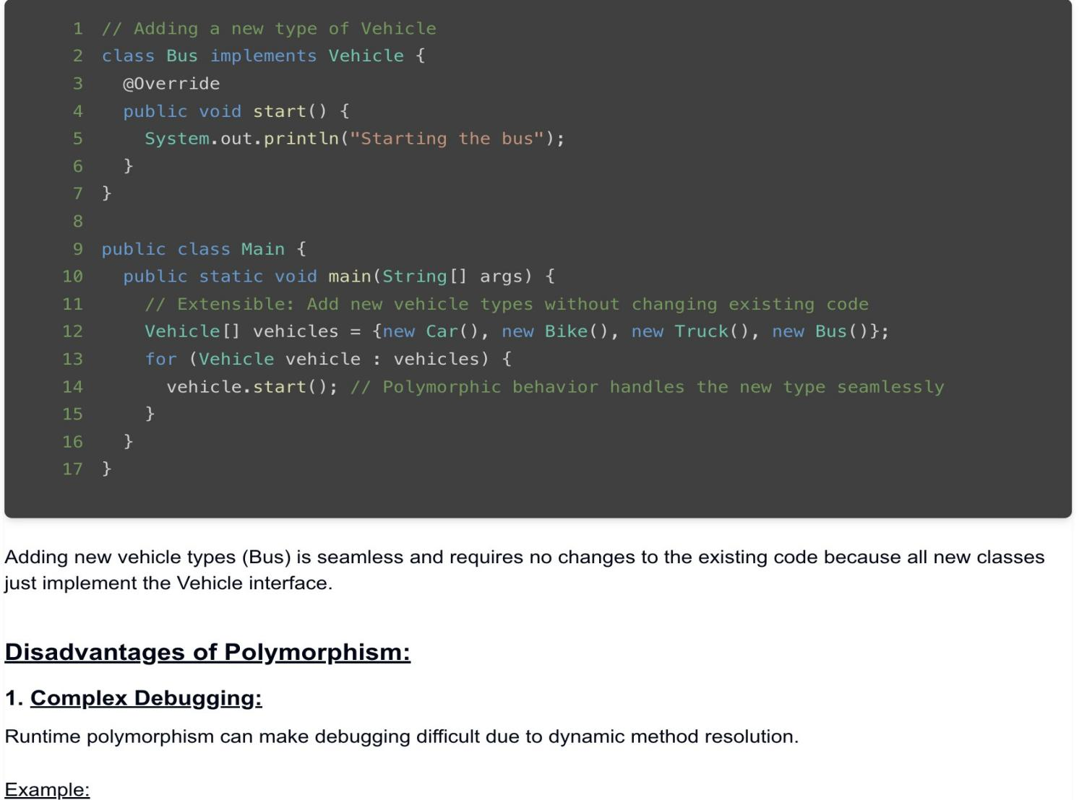

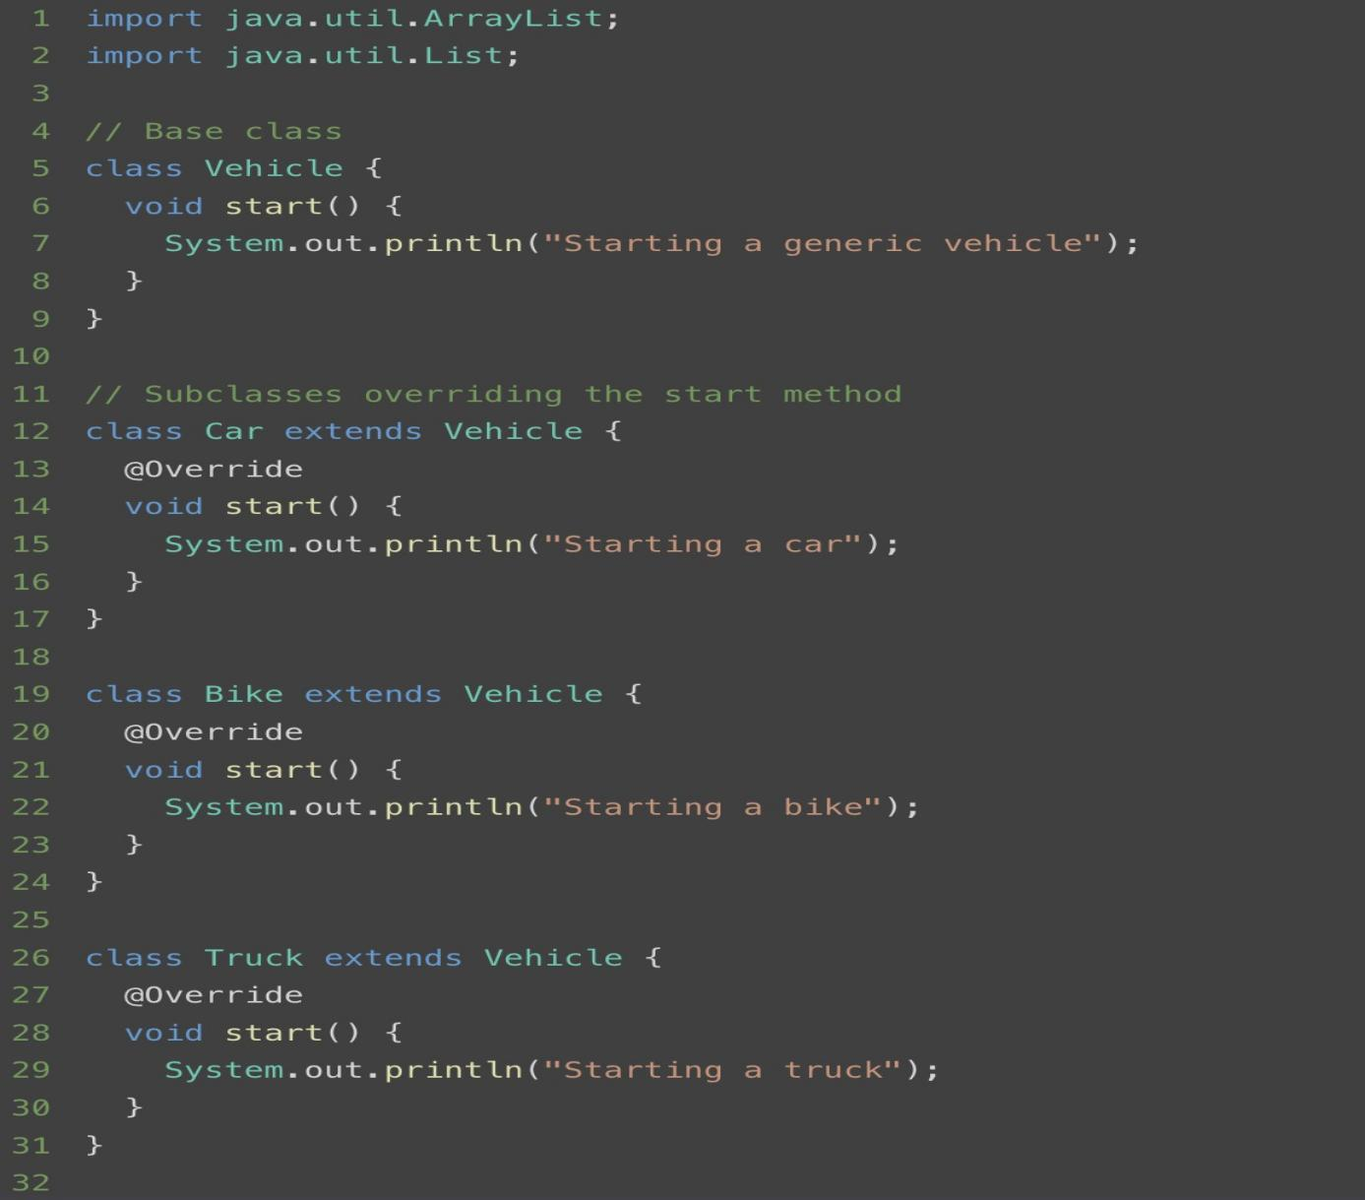
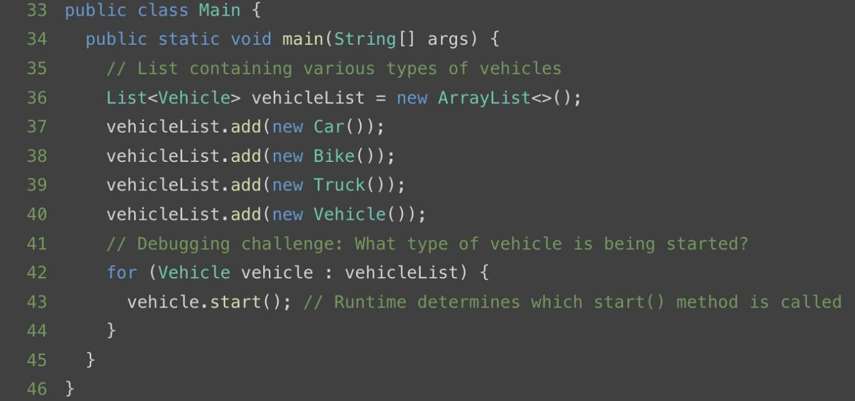
When iterating through a list of Vehicle objects, it’s unclear during debugging which specific subclass (Car, Bike, Truck, or Vehicle) is being called without stepping through the code or inspecting runtime variables.

If the list comes from an external API, file, or database, the actual type of each object isn’t clear from the source code, making it difficult to debug.

2. Performance Overhead:
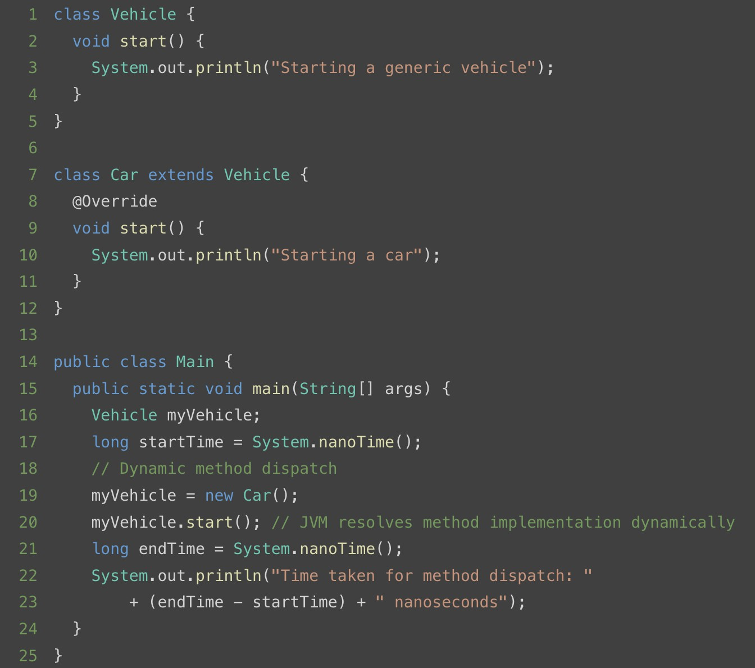
Dynamic method dispatch introduces slight overhead as the JVM resolves the method during runtime.

Inheritance and It's types
Inheritance is a cornerstone of Object-Oriented Programming (OOP) that facilitates code reuse and establishes a hierarchical relationship between classes. By inheriting properties and methods from a parent class, a subclass can extend or override functionalities, enabling efficient and scalable application development. ⚙️🔄
‍
This promotes code reuse, reduces redundancy, and supports polymorphism, making applications easier to develop and maintain. 💻✨
‍

Types of Inheritance:

1. Single Inheritance:
In single inheritance, a subclass inherits from a single parent class. This is the simplest form of inheritance and is widely used in Java.
‍
Example :
class Animal
{
void eat()
{
System.out.println("This animal eats food.");
}
}
class Dog extends Animal
{
void bark()
{
System.out.println("The dog barks.");
}
}
public class Main
{
public static void main(String[] args)
{
Dog dog = new Dog();
dog.eat(); // Inherited method
dog.bark();
}
}

🔑Key Features:
• A single subclass derives from one superclass.
• Promotes simplicity and clarity in the inheritance hierarchy.
‍

2. Multilevel Inheritance :
In multilevel inheritance, a class inherits from a parent class, and another class further inherits from this child class, forming a chain.
‍
Example :
Java
class Animal {
void eat() {
System.out.println("This animal eats food.");
}
}
class Mammal extends Animal {
void walk() {
System.out.println("This mammal walks.");
}
}
class Dog extends Mammal {
void bark() {
System.out.println("The dog barks.");
}
}
public class Main {
public static void main(String[] args) {
Dog dog = new Dog();
dog.eat(); // Inherited from Animal
dog.walk(); // Inherited from Mammal
dog.bark();
}
}
‍
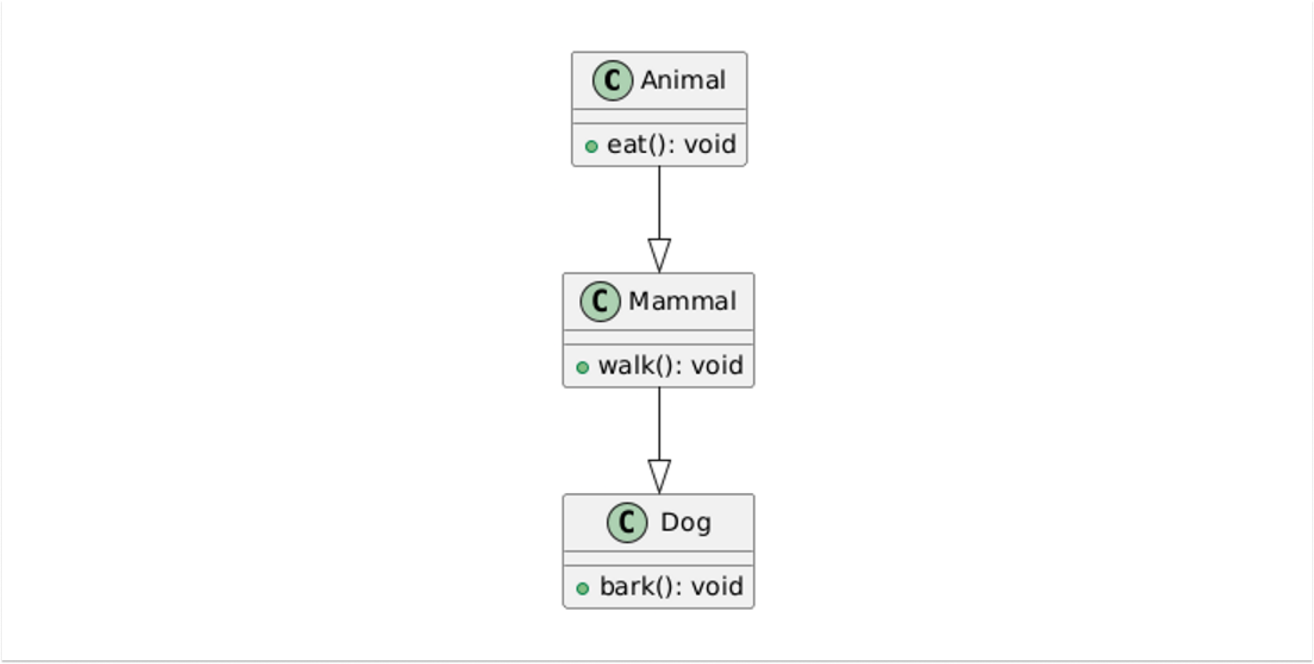
‍
🔑 Key Features:
• Establishes a chain of inheritance.
• Enables deeper specialization of classes.
‍

3. Hierarchical Inheritance :
In hierarchical inheritance, multiple subclasses inherit from a single parent class. This allows different classes to share common properties and behaviors defined in the superclass.
‍
Example :
class Animal {
void eat() {
System.out.println("This animal eats food.");
}
}
class Dog extends Animal {
void bark() {
System.out.println("The dog barks.");
}
}
class Cat extends Animal {
void meow() {
System.out.println("The cat meows.");
}
}

public class Main {
public static void main(String[] args) {
Dog dog = new Dog();
dog.eat();
dog.bark();
Cat cat = new Cat();
cat.eat();
cat.meow();
}
}
‍
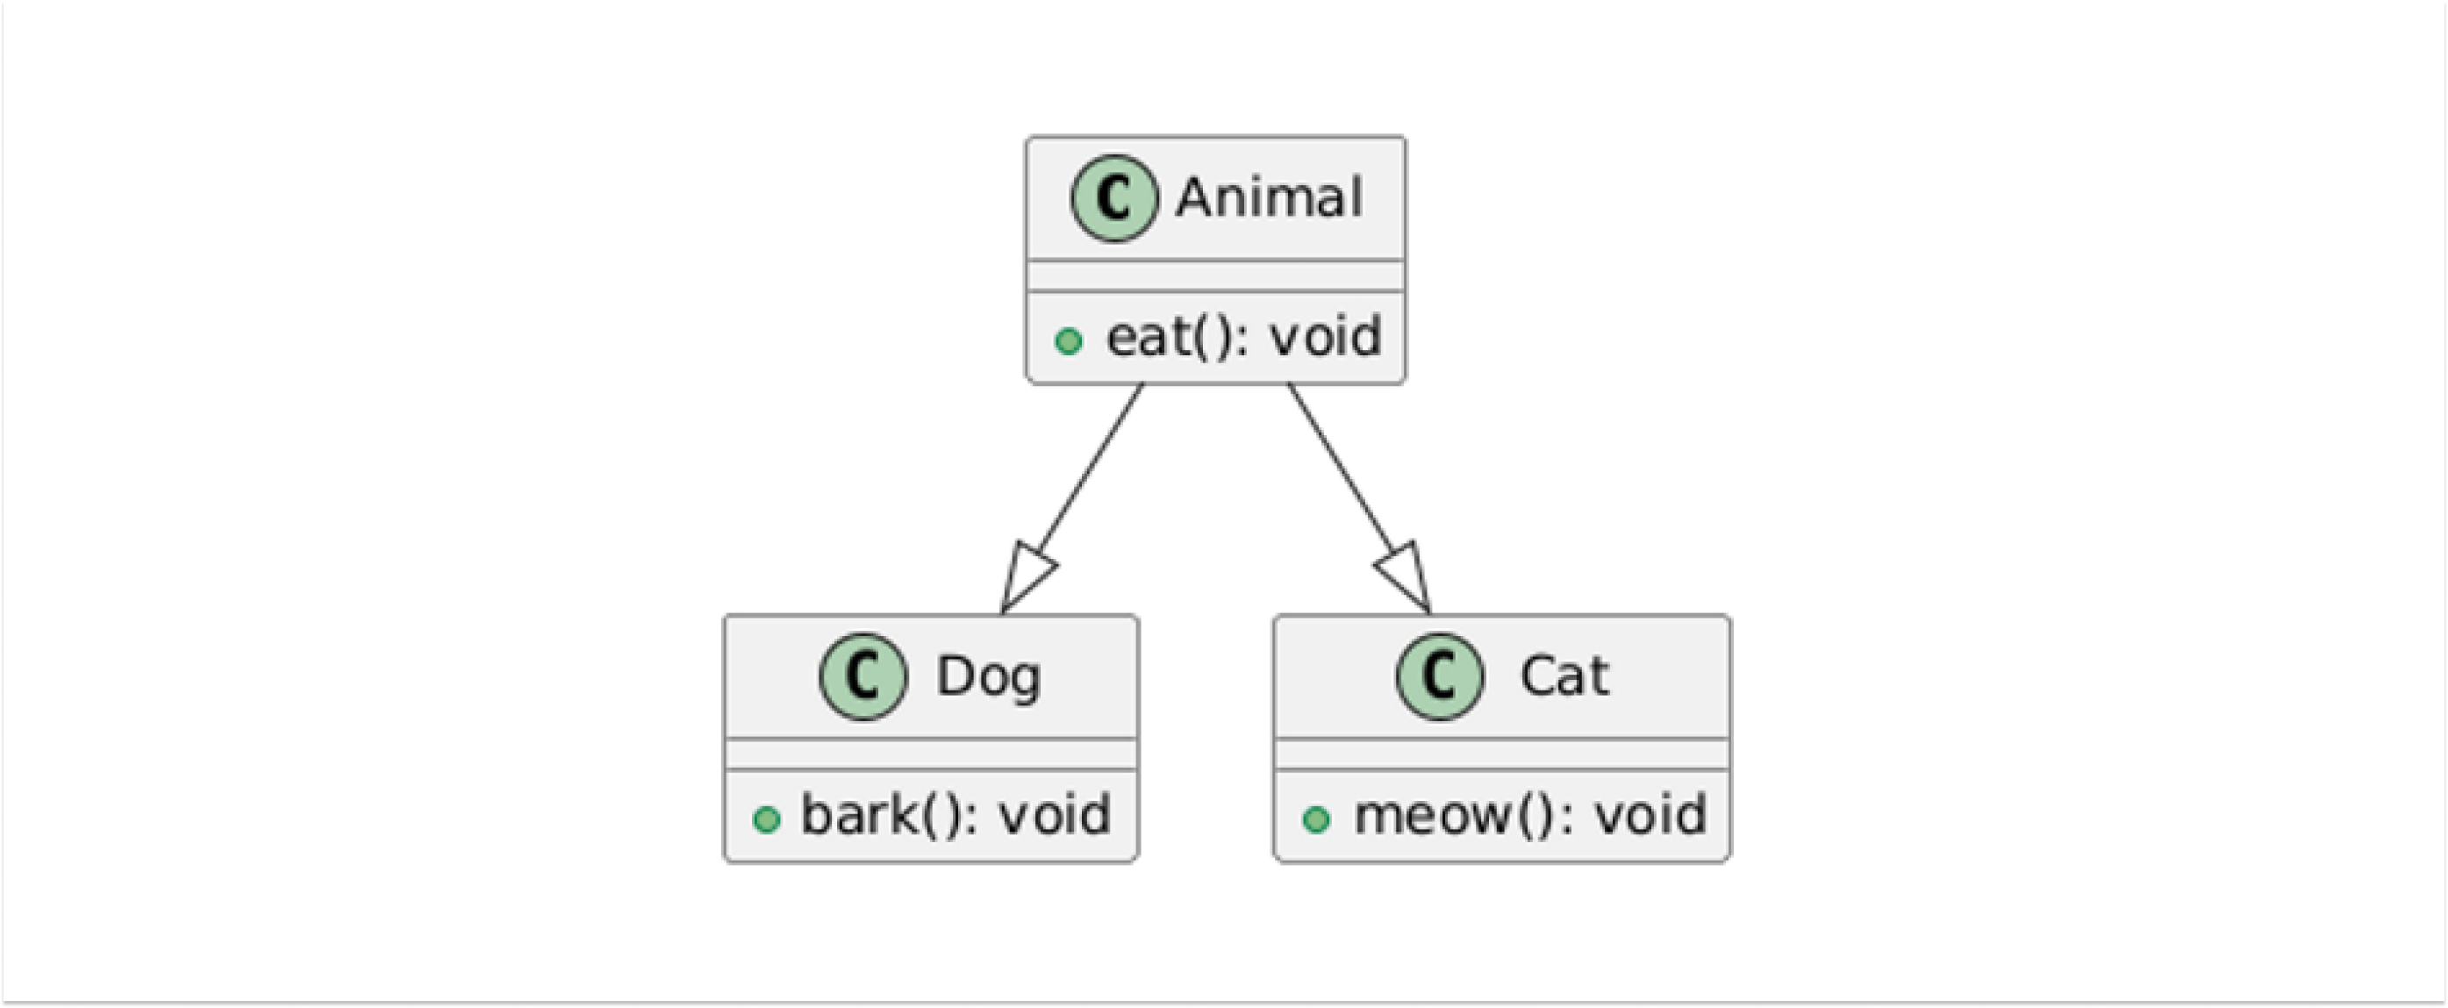
‍
🔑 Key Features:
• Multiple subclasses share common properties from a single superclass.
• Promotes code reuse and modularity.
‍

4. Multiple Inheritance :
Java does not support Multiple inheritance directly due to the diamond problem, but it can be achieved using interfaces. In Multiple inheritance, A single class can inherit properties from multiple interfaces.

‍

💎 What is the Diamond Problem?
The diamond problem arises in languages that allow multiple inheritance with classes. Imagine a scenario where a class inherits from two parent classes that both have a method with the same name. If the child class does not override the method, it creates ambiguity as to which implementation the child class should inherit. This leads to confusion and potential conflicts in the program.
‍
Problem Example :
Java
class Animal {
public void sound() {
System.out.println("Animal makes a sound");
}
}
class Dog extends Animal {
@Override
public void sound(){
System.out.println("Dog barks");
}
}
class Cat extends Animal {
@Override
public void sound() {
System.out.println("Cat meows");
}
}// Not supported in Java
public class HybridAnimal extends Dog, Cat {
public static void main(String[] args){
HybridAnimal hybrid = new HybridAnimal();
hybrid.sound(); // Creates ambiguity: Should it call Dog's sound() or Cat's sound()?
}
}
‍
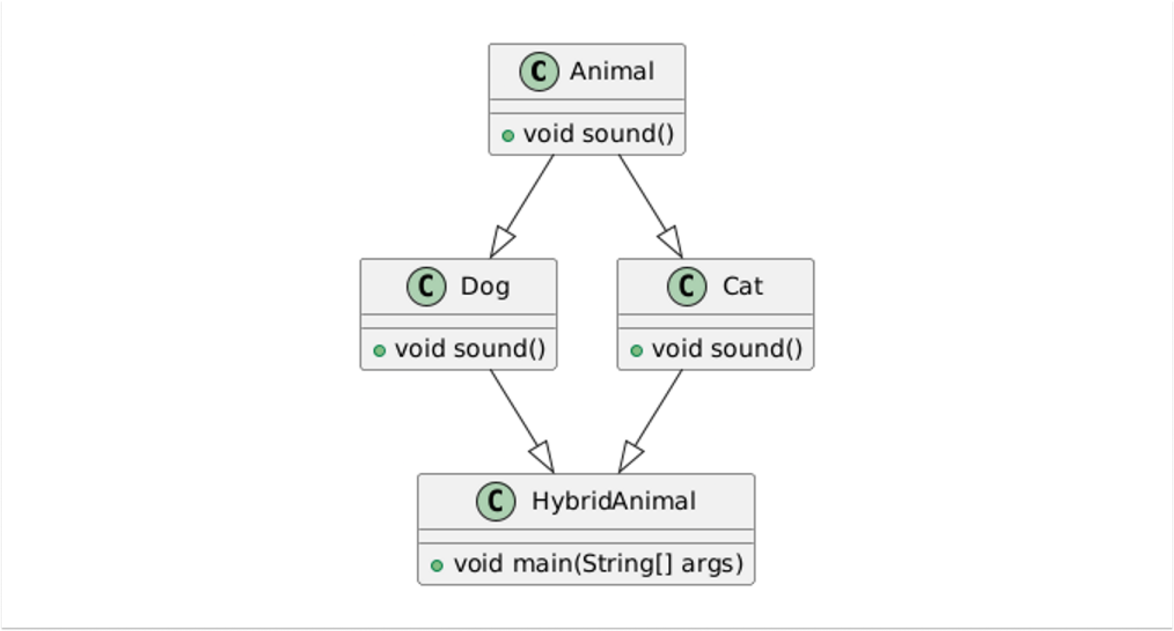
‍
🧠 How Java Resolves This?
Java avoids this problem by not allowing multiple inheritance with classes. Instead, Java provides interfaces as a way to achieve multiple inheritance.
‍
When a class implements multiple interfaces, it must provide implementations for the methods defined in the interfaces. This eliminates ambiguity since the child class explicitly defines the behavior of inherited methods.
‍
Solution Example :
Java
interface Dog {
void sound();
}
interface Cat {
void sound();
}
public class HybridAnimal implements Dog, Cat {
@Override
public void sound() { // You can define custom logic to decide which sound to make
Dog.super.sound(); // Calls Dog's sound()
// Cat.super.sound(); // Or you can choose to call Cat's sound()
}
public static void main(String[] args) {
HybridAnimal hybrid = new HybridAnimal();
hybrid.sound(); // Calls Dog's sound
}
}
‍
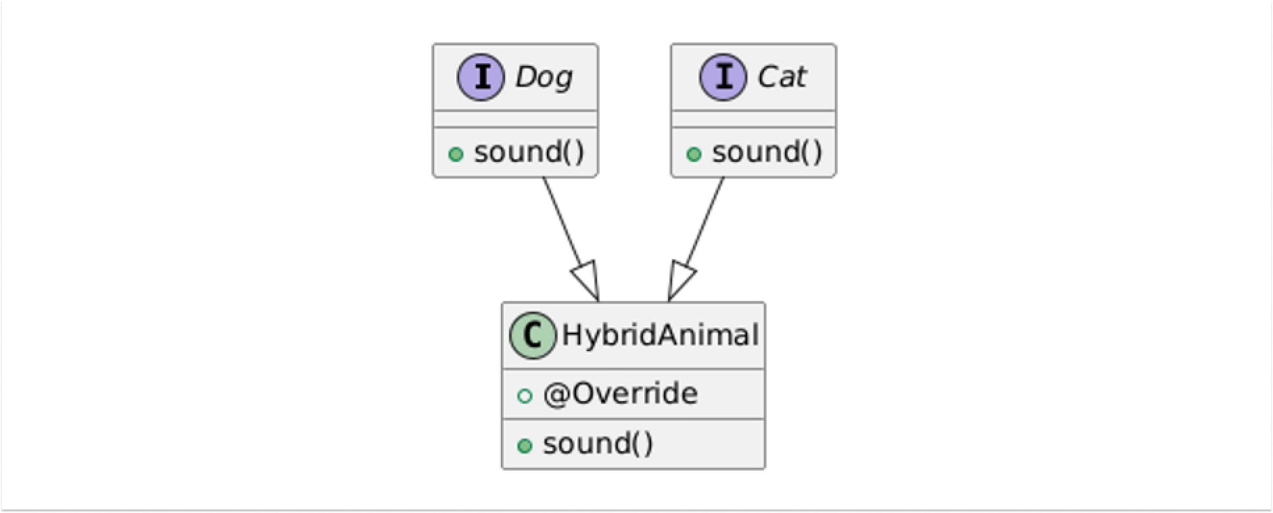
‍
🔑Key Features:
• Achieved using interfaces to avoid ambiguity caused by multiple inheritance.
• Combines the benefits of various inheritance types.
‍

5. Hybrid Inheritance :
Hybrid inheritance is a combination of more than one type of inheritance. It can involve both single inheritance and multiple inheritance.
‍
In Java, hybrid inheritance is achieved by combining classes and interfaces. Since Java doesn't support multiple inheritance with classes (to avoid the diamond problem), this type of inheritance can only be implemented using interfaces alongside class inheritance.
‍‍
Example :
Java
// Single inheritance
class Animal {
void eat() {
System.out.println("The animal eats food.");
}
}
// Interface for multiple inheritance
interface Mammal {
void walk();
}
// Interface for multiple inheritance
interface Pet {
void play();
}
// Hybrid inheritance using a combination of class and interfaces
class Dog extends Animal implements Mammal, Pet {
@Override
void eat() {
System.out.println("The dog eats food.");
}
@Override
public void walk() {
System.out.println("The dog walks.");
}
@Override
public void play() {
System.out.println("The dog plays fetch.");
}
}
public class Main {
public static void main(String[] args) {
Dog dog = new Dog();
dog.eat();
dog.walk();
dog.play();
}
}
‍
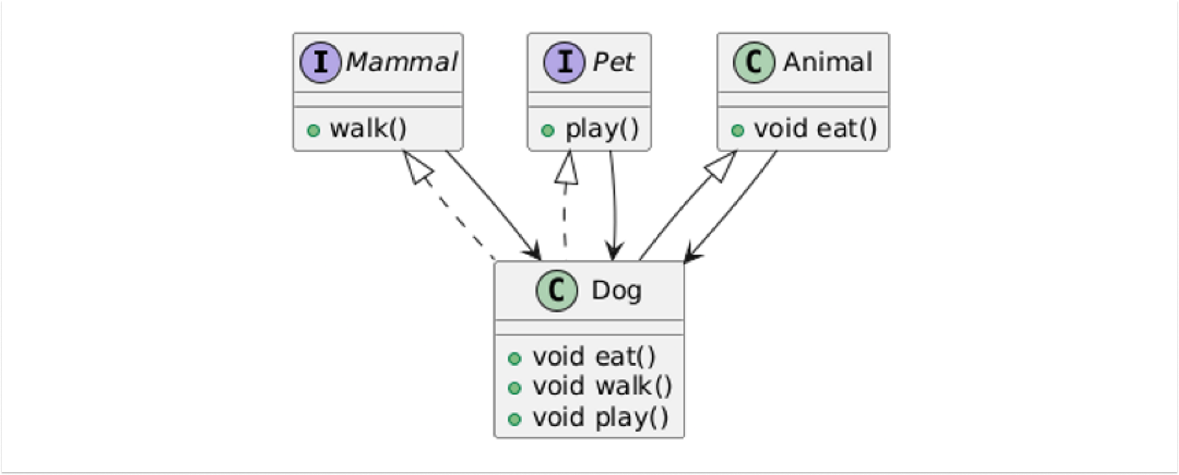
‍

👍🏼Advantages of Inheritance :

1. Code Reusability:
Enables reuse of existing code, reducing redundancy and effort.
‍
Example :
Java
class Animal {
public void eat() {
System.out.println("Animal is eating");
}
}
class Dog extends Animal { // Inherits eat() method from Animal}
class Main {
public static void main(String[] args) {
Dog dog = new Dog();
dog.eat(); // Reuses the eat method from Animal
}
}
‍

2. Ease of Maintenance:
Centralizes common functionality, making updates and bug fixes more manageable.
‍
Example :
Java
class Animal {
public void eat() {
System.out.println("Animal is eating");
}
}
class Dog extends Animal { // Inherits eat() method from Animal}
class Cat extends Animal { // Inherits eat() method from Animal}
public class Main {
public static void main(String[] args) { // If we need to fix a bug in eat()
// or improve it, we only need to do it in Animal
Animal animal = new Dog();
animal.eat(); // Animal is eating
animal = new Cat();
animal.eat(); // Animal is eating
}
}
‍
If we need to fix a bug in start() method or refactor it, we only need to do it in the Vehicle Class and it will be implemented for all the sub classes of the Vehicle Class.
‍

3. Extensibility:
Allows developers to extend functionality without altering existing code.
‍
Example :
class Animal {
public void sleep() {
System.out.println("Animal is sleeping");
}
}
class Dog extends Animal {
@Override
public void sleep() {
System.out.println("Dog is sleeping in its kennel");
}
}
class Cat extends Animal {
@Override
public void sleep() {
System.out.println("Cat sleeps in a tree");
}
}
class Main {
public static void main(String[] args) {
Animal myAnimal = new Animal();
Animal myDog = new Dog();
Animal myCat = new Cat();
myAnimal.sleep(); // Animal is sleeping
myDog.sleep(); //Dog is sleeping in its kennel
myCat.sleep(); // Cat sleeps in a tree }}
‍
In this example, Dog and Cat both inherit the sleep() method from Animal. You can extend the functionality of the sleep() method in each subclass by overriding it to add specific behavior for each subclass (Dog sleeping in a kennel, Cat sleeping in a tree).
‍
This is an example of extensibility—you don’t need to modify the Animal class itself to extend its behavior for each subclass. You only need to add new behavior or change behavior in the subclasses as needed.
‍
Inheritance makes it easier to add new types of animals with different sleeping behaviors by extending Animal without changing the original Animal class.
‍

4. Supports Polymorphism:
Facilitates runtime polymorphism, enabling dynamic behaviour.
‍
Example :
Java
class Animal {
public void sound() {
System.out.println("Animal makes a sound");
}
}
class Dog extends Animal {
@Override
public void sound() {
System.out.println("Dog barks");
}
}
class Cat extends Animal {
@Override
public void sound() {
System.out.println("Cat meows");
}
}
class Main {
public static void main(String[] args) {
Animal myAnimal = new Dog();
myAnimal.sound(); // Dog barks
myAnimal = new Cat();
myAnimal.sound(); // Cat meows
}
}
‍

👎🏼Disadvantages of Inheritance :

1. Increased Coupling:
Creates a tightly coupled relationship between classes, making changes in the superclass impact all subclasses.
‍
Example :
Java
class Animal {
public void eat() {
System.out.println("Animal eats");
}
}
class Dog extends Animal { // Inherits eat() method from Animal}
class Main {
public static void main(String[] args) {
Dog dog = new Dog();
dog.eat(); // Reuses the eat method from Animal
}
}
‍
If we change Animal's eat method, it could break Dog's functionality leading to an Exception which shows how a change in one particular method of the Parent class can break the properties of it's subclasses.
‍

2. Complexity:
Overuse of inheritance can lead to overly complex and hard-to-maintain hierarchies.
‍
Example :
Java
class Animal {}
class Mammal extends Animal {}
class Dog extends Mammal {}
class Bulldog extends Dog {}
class Main {
public static void main(String[] args) {
Bulldog bulldog = new Bulldog();
}
}
‍
Understanding this deep nested level of inheritance structure may be difficult in larger systems to maintain and may require refactoring to make the structure more maintainable and scalable.
‍

3. Reduced Flexibility:
A subclass is heavily dependent on the implementation of its superclass, which may limit customization.
‍
Example :
Java
class Animal {
public void sleep() {
System.out.println("Animal is sleeping");
}
}
class Dog extends Animal { // The dog inherits the sleep method from Animal}
class Cat extends Animal { // Similarly, the Cat class inherits the sleep method from Animal}
class Main {
public static void main(String[] args) {
Animal dog = new Dog();
Animal cat = new Cat();
dog.sleep(); // Animal is sleeping (not customized for Dog)
cat.sleep(); // Animal is sleeping (not customized for Cat)
}
}
‍
In this example, the Dog and Cat classes are both inheriting the sleep() method from Animal. However, suppose you wanted to make Dog sleep in a specific way, for instance, "Dog is sleeping in its kennel" 🐶🏠 and Cat sleep in another way, "Cat sleeps in a tree" 🐱🌳.
‍
You would be forced to modify the sleep() method in the parent class, Animal, or override it in each subclass. This reduces flexibility because you can't change or extend sleep() behavior independently for each subclass without affecting the others.

